Programing
This the programming part of the test. For this section, all the questions are independent of the other sections, you can answer the questions in any order. One answer does not depend of another answer.
To answer the following questions, please use the attached dataset for reference Annex 1 - REACH TEST DATA. You can use any software.
Please share all the files as well as your project. You can use any package you want. You can use any programing language (R or Python, etc) you want but it has to be a scripted file such as .rmarkdown, .qmd, .ipynb, .py , etc.

Packages
Please make sure to install any packages you will be using.
library(tidyverse)

Question 12
Some household replied not having a hand-washing facility and washing their hands more than 7 times a day. You are asked to add a new variable to the dataset called handwashing_check that follow this definition:
- TRUE : when the variable handwashingfull is “No Handwashing facility” and the variable Frequency.respondant.report.handwhashing.a.day is “7 times and more”.
- FALSE : if the above conditions are not met.
The new column should be a logical. Please save the dataframe with the new column.
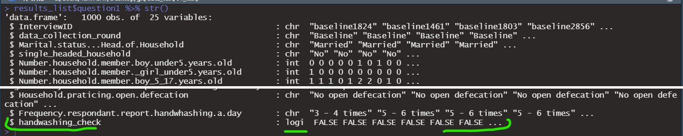

Question 13
After checking your dataset, you have realised there were some mistakes. Please change the following values according to this cleaning log. You can also find it in the cleaninglog.csv file in the data folder.
- Interview ID : The interview ID.
- variable : The name of the variable to be changed.
- old.value : The current value in the dataset.
- new.value : The value to be changed to.
- Issue: why this was flagged.
- feedback: The feedback received from the team.
InterviewID | variable | old.value | new.value | issue | feedback
baseline1000 | diarrhea_under_5 | Yes | NA | Respondent say there was a case of diarrhea but there is no children under 5. | No children in the household, confused with older child
uuid:fde636f2-60d5-4c61-bdb8-be783b8e207f | Improvedsanitationfacility | Improved toilet facility | Unimproved toilet facility | The respondent said s/he has an improved sanitation facility but practice open defecation | Confirmed there is no improved facility.
Please save the clean dataset. The dataset may have any additional columns as long as you have the initial 24 columns.

Question 14
We want to know the count and the proportion of the type of household for each round of data collection. Please provide a summary table with 4 columns:
- data_collection_round: the round of data collection (variable : data_collection_round).
- house_type: the type of house (variable: house_type).
- n: number of respondent living the given option for the given round.
- prop: the proportion of respondent living in the given option for the given round.
The results should be a 10 x 4 data.frame.
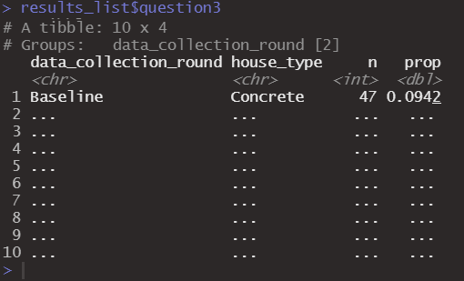

Question 15
Make a function that checks for outliers. The function should take one argument called column_to_check, a vector or column of a data frame. It should return a vector a logical vector if the value is an outlier or not.
An outlier will be defined as “a value that is outside of 3 standard deviation from the mean”.
Missing value should be ignored.
Results should be a function.

Question 16
The data collection took place in 2 locations but the information was lost in some manipulations. Luckily, the partner organisation gave you a list of the ID’s and the village. Please add back the villages in the dataset. You can find the list of villages in file village.csv in the data folder.
Please save the dataset with the village column. The dataset may have any additional columns as long as you have the initial 24 columns and the village column.

Question 17
Complete this code to be able to reproduce this graph. 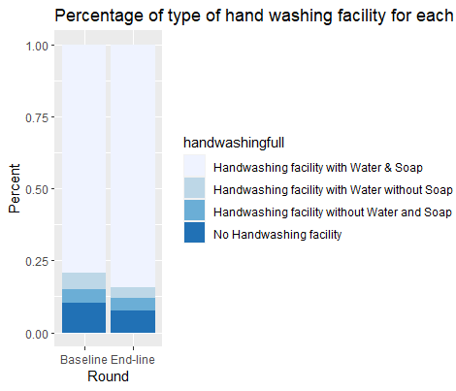
#Please remove the `eval = F`or change it to `eval = T`. The rmarkdown would not run if there is a mistake in the code.
mydataset %>%
ggplot(aes(x = ..., ... = handwashingfull)) +
geom_...(... = ...) +
scale_fill_brewer() +
labs(x = ..., y = ...,
title = "Percentage of type of hand washing facility for each round")

Question 18
We want to know how many NA are present in the dataset for each column. Using a function from map family or apply family, create a list that counts how many missing value there are. There is no need to simplify the results.
Please make sure that at least all the variables from the initial dataset (Annex 1 - REACH TEST DATA.csv) are present (the list should have minimum 24 object inside).

